AI ASSISTED CODING

Lab test:2

Name: G.Gopi Chand

batch no: 11

hall ticket no:2403a51237

Task:1

Subgroup G

G.1 — [S18G1] Sum CSV column ignoring bad rows

Context:

CSV exports in real estate listings platform have invalid numerics.

Your Task:

Sum 'value' ints; skip invalid rows.

Data & Edge Cases:

id,value

1,10

2,NA

3,7 -> 17.

AI Assistance Expectation:

Use AI to draft csv.DictReader solution and tests.

Constraints & Notes:

Optionally report skipped count.

Sample Input

id,value  
1,10  
2,NA  
3,7

Sample Output

17

Acceptance Criteria: Skips invalid rows; correct total

Prompt:

“Write a Python program using csv.DictReader to sum the integer values in the value column of a CSV, skipping invalid rows (e.g. NA), and output the total.”

Code:

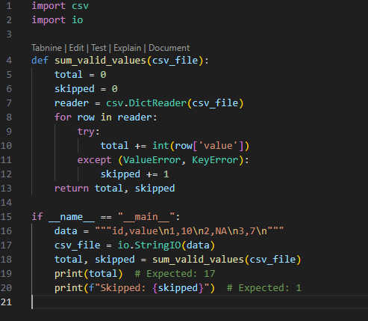

Output:



Task:2

### G.2 — [S18G2] Merge two CSVs by id

Context:

Merge two CSVs in real estate listings platform by id.

Your Task:

Implement inner & left joins without pandas.

Data & Edge Cases:

A:id,price; B:id,qty.

AI Assistance Expectation:

Dict map + loops; add tests.

Constraints & Notes:

Stable order preferred.

Sample Input

id,price  
A,10  
B,20  
---  
id,qty  
A,2  
C,5

Sample Output

inner=[('A',10,2)], left=[('A',10,2),('B',20,None)]

Acceptance Criteria: Correct semantics

Prompt:

“Write a Python program (without pandas) that merges two CSV files by id using csv.DictReader, implementing both inner and left joins with dicts/loops, and outputs the correct tuples.”

Code:

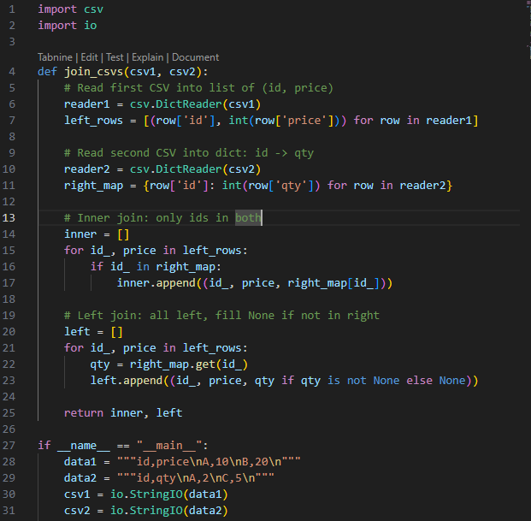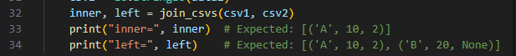

Output:

